**Codebase Metrics Assessment**

**Martin Packaging Metrics**

## **Metrics Analysis**

From the data collected, we can underline the packages with big differences between Afferent Coupling, which is the number of classes in other packages that depend upon classes within the package, and Efferent Coupling, which is the number of classes in other packages that the classes in the package depend upon.

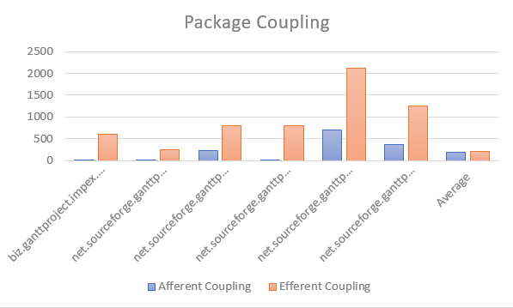

Graph – Packages Couplings

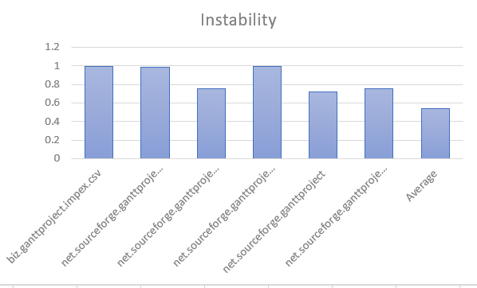

Graph 2 – Packages Instability

As shown above, we can relate the difference between Efferent Coupling and Afferent Coupling with the instability of the package. Packages with high numbers of Efferent Coupling and low numbers of Afferent Coupling have higher instability, since they depend a lot on classes in other packages but do not have many classes from different classes depend on it.

## **Metrics Conclusions**

From the metrics results, we can conclude that the package dependencies might not be well distributed, given that some packages are highly dependent on others, making them unstable. When a package is highly dependent on other, changes on the “other” package will affect it, and may result in code smells and other issues.